**PERFORMANCE ANALYSIS AND INSIGHTS SUMMARY**

**1. PERFORMANCE METRICS**

• Overall accuracy: 85%

• Improvement rate: +15% in last month

• Topics mastered: 5

• Total quizzes completed: 14

**2. VISUALIZATION INSIGHTS**

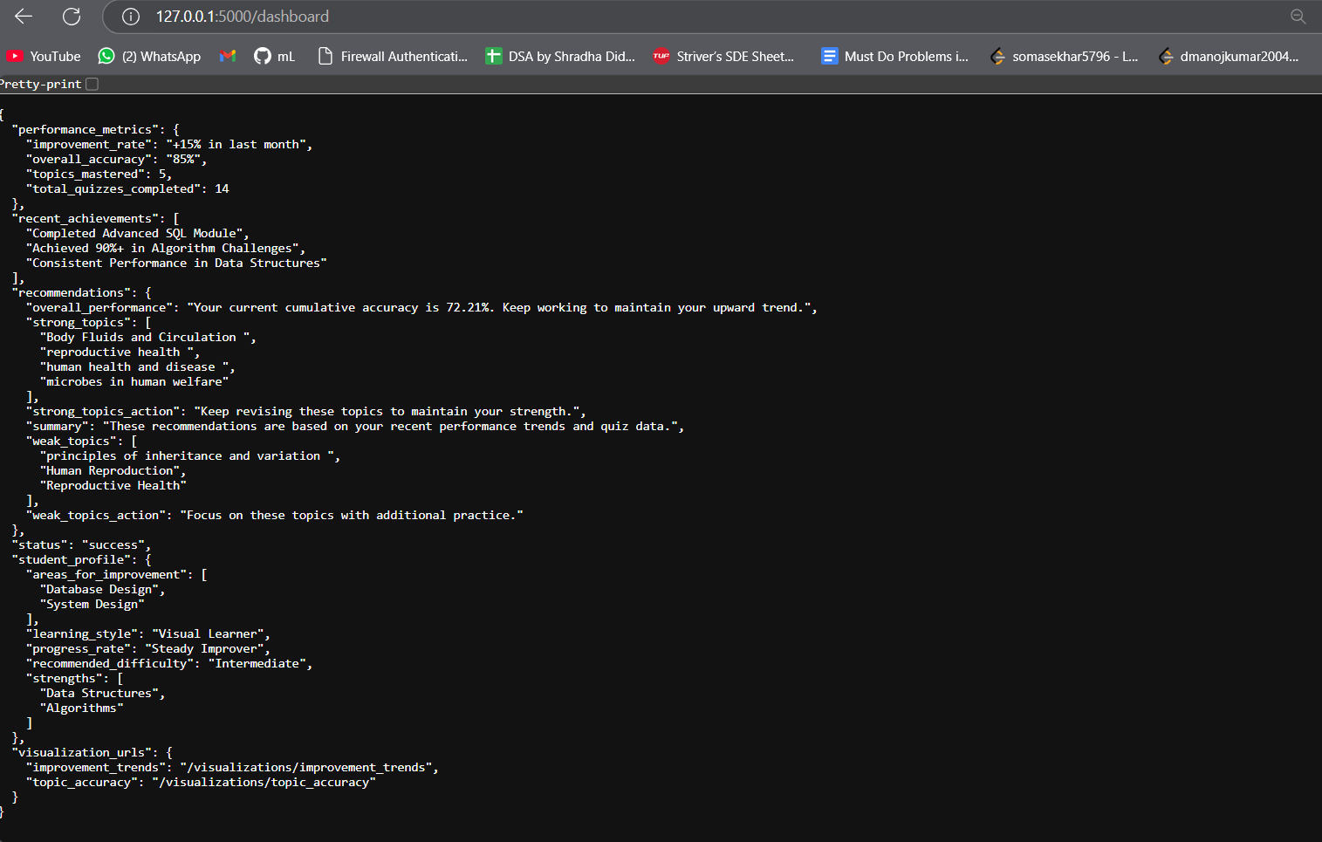

**A. Accuracy Trend Analysis:**

- Initial decline until late December 2024

- Sharp upward trend in January 2025

- Peak performance reaching nearly 100%

- Shows successful learning adaptation

**B. Speed vs Accuracy Analysis:**

- Variable performance across attempts

- No direct correlation between speed and accuracy

- Scores range from 30% to 100%

- Suggests focus on accuracy over speed

**C. Mistake Distribution:**

- Primary cluster of errors in 0-5 range

- Secondary cluster around 15-20

- Indicates consistent performance with occasional challenges

**3. TOPIC BREAKDOWN**

**STRONG TOPICS:**

• Body Fluids and Circulation

• Reproductive Health

• Human Health and Disease

• Microbes in Human Welfare

**NEEDS IMPROVEMENT:**

• Principles of Inheritance and Variation

• Human Reproduction

• Reproductive Health

**4. STUDENT PROFILE**

• Learning Style: Visual Learner

• Progress Rate: Steady Improver

• Difficulty Level: Intermediate

• Core Strengths: Data Structures, Algorithms

**5. KEY RECOMMENDATIONS**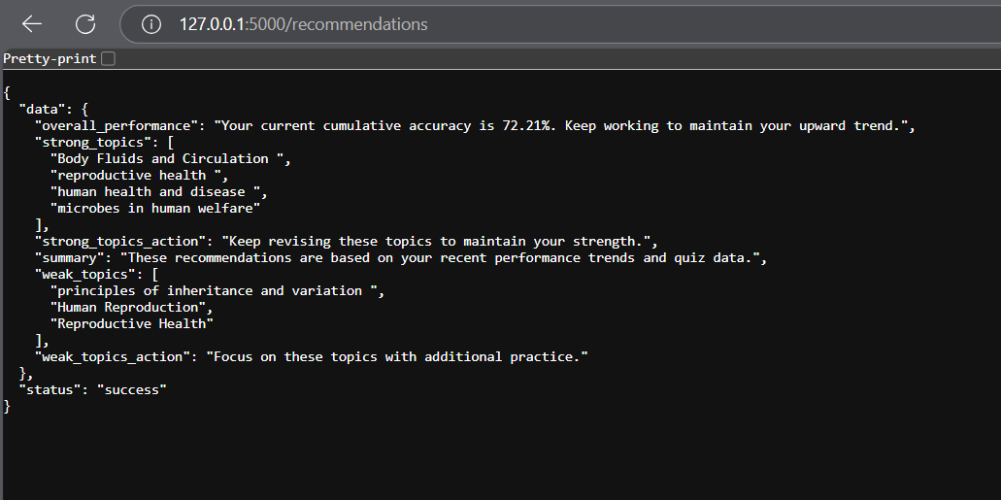

1. Maintain current performance in strong topics

2. Increase practice in weak areas

3. Current cumulative accuracy: 72.21% - Continue upward trend

4. Focus on consistent performance across all topics

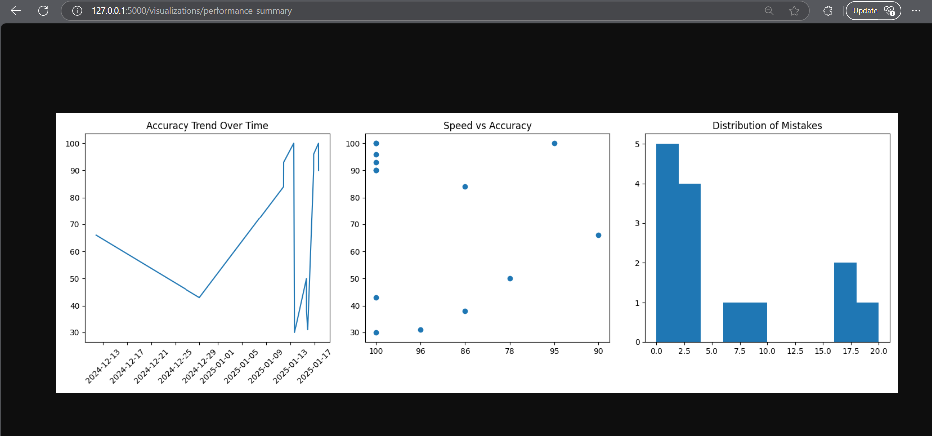

**6. RECENT ACHIEVEMENTS**

• Completed Advanced SQL Module

• Achieved 90%+ in Algorithm Challenges

• Consistent Performance in Data Structures

**7. CONCLUSION**

Student shows promising progress with clear strengths and identifiable areas for improvement. Recent performance trends indicate effective learning strategies and good potential for continued growth.